Marcus Campbell Goodall was born in 1914 in London and educated at the Uppingham School and Balliol College, Oxford. He was sent down from Oxford not on academic grounds but for some mischief involving an automobile. In 1936, after having applied for admission into the Air Force and been turned away, he received a personal note from then Master of Balliol, Alexander Dunlop Lindsay (Lord Lindsay of Birker), exclaiming that he would see what could be done but that [Marcus was] “not otherwise a very easy person to fit into a job...”

In 1942 he was summoned into service as an experimental officer to the British Admiralty Signals Establishment in the scientific and technical pools at Royal Fort, Bristol. In 1944, he applied for a patent on a UHF apparatus he was developing but which was never processed as the specification presented was provisional and apparently never completed. A couple of years later he was to have collaborated with W. E. Boyd of Boyd Medical Research Trust, Glasgow for the further development of this apparatus for the measurement of absorption spectra and heterodyne experiments, the results of which are unknown.

In June of 1945, he received a letter from Dr. Albert W Hull of General Electric acknowledging his design of the triode oscillator and that it had excited the admiration of a number of people at General Electric and he expressed an interest in having Marcus join their research team. By this time, Marcus had already joined the research staff of Marconi’s Wireless Telegraph Company in Essex.

While at Marconi’s, he wrote a manuscript entitled “New Foundations of Physical Field Theory” and another titled “P-adic Statistics and Elementary Particles”, both of which were rejected by The Physical Review-Reviews of Modern Physics, Minneapolis, as it was seen that readers would be unable to derive its meaning. He also wrote a paper on the Foundations of Quantum Theory which was reviewed by Professor Rosenfeld of the Physical Laboratories, University of Manchester in 1948 and for which he received a very colorful reply, including comments that his was “an extremely original approach” and called his manuscript “tantalising”. During these years, from 1945 to 1949, he received numerous correspondences from Albert Einstein, Max Born, and Otto Frisch who referred his work to [Paul] Dirac, claiming he might be the only person to understand it. Dirac was unwilling to “plough through the mathematics” of it, and ultimately the work was referred to John von Neumann, then at Manchester. Professor W. D. Hodge also promised to write to Neumann on his behalf.

In May 1949, Mr. Goodall was awarded the Leverhulme research fellowship with which he was accepted for study at the Institute for Advanced Studies, Princeton. As he had not taken a degree from Oxford, special consideration was given him and he began his studies there in the fall of 1949.

In the summer of 1950, he received a personal letter from Albert Szent-Gyorgyi inviting him to work with him at the Marine Biological Laboratory in Woods Hole, Massachusetts (now known as the Woods Hole Oceanographic Institute). No information is available as to the dates or nature of his work there, but it is known that he was stationed there for some time in the 1950s.

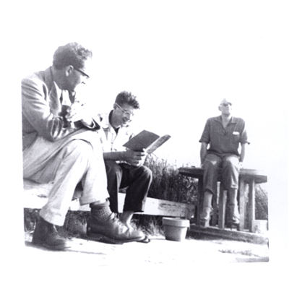
[Marcus Goodall, Gabor Miskolczy, Albert Szent-Gyorgyi, Seven Winds Beach]

From Woods Hole, he went on to the Research Laboratory of Electronics at MIT where worked alongside Warren McCullough and published numerous papers. While at MIT, he authored a book titled “Science and the Politician” (Schenkman Publishing Company, Cambridge) in which his focus is upon “not merely the physical consequences, but the intellectual content of what is called Science [which] has changed irrevocably, and with it the significance for humanity.”

In 1960 while at MIT, he met and married Janet Fauntleroy McKenney and in 1965 was awarded a grant to study with the Institute for Biomedical Research at the American Medical Association in Chicago. In 1970, he took a position in the Laboratory of Molecular Biophysics at the University of Alabama, Birmingham.

In 1987, he retired and return to the United Kingdom where he lived until his death in 1998 in Durham where he had continued his studies and had become interested in color theory. His second book, “Science, Society and the West” (Durham Academic Press) was published posthumously and is essentially a brief history of the importance of science and the role it has played during the 20th century as well as a warning to politicians, economists, and scientists not to ignore the moral consequences of their actions with regard to the future of science and mankind.

He was a member of the London Mathematical Society, the American Mathematical Society, and the Royal Society, London.

Biographical sketch kindly provided by his daughter Stella Goodall.

