RCA Heape Military Record

13/02/24 | Born | Natal, S. Africa
04/02/42 | Enlisted  Trade on enlisting: Student | w Middx Rgt  24 Machine Gun Training Cntr | Age 18/00/22  Service Number  375248
26/02/42 | Date service start | Rank Pte | Age 18/01/13
17/07/42 | Accepted for training at an OCTU | Officer Cadet Training Unit
31/07/42 | Interviewed and accepted for service in India
20/08/42 | Attached to RAC | Royal Armoured Corps
03/09/42 26/11/42 | Voyage to India | 74 days
26/11/42 | Reported for training OTS Mhow, India | Officer Training School
03/04/43 | Passed out OTS Mhow
04/04/43 | Posted to 42nd Cavalry IA on emergency commission | 2nd Lieut  Indian Army | Squadron Officer
29/12/43 | Promoted to Lieut & Transferred to 43rd Cavalry IA | Lieut Indian Army  Served India, Burma Arakan  See 2nd Arakan Campaign timeline below
06/45 | Promoted to Capt & transferred to 3 Armoured Replacement | Capt  Indian Army
11/45 | Transferred to 43rd Cavalry IA | Served Malaya, Java, India
26/11/45 | Embarked Madras
01/12/45 | Disembarked Singapore
20/02/46 | Embarked Singapore
25/02/46 | Disembarked Batavia, Java
26/06/46 | Departed Java
08/46 | Transferred to 18th King Edward’s Own Cavalry IA
19/08/46 | India Military Academy  Dehradun, Uttarakhand
22/11/47 | Transferred from Special List to be Lieut 9th Lancers
02/01/48 | Posted to RAC depot, Bovington | On Leave
01/02/48 | Transferred from RAC Depot to 9th Lancers | Lieut
08/10/48 | Promoted to Capt and attached to Scottish Command G Branch | Capt  Staff Learner
16/08/49 | Attended ?? School for course LA9
23/12/49 | As 9th QRL posted to QO Yorkshire Dragoons & appointed as adjutant
21/10/51 | Relinq ADJJ Yorks Dgns TOS Depot | Taken on strength
07/11/51 | Embarked UK and TOS BAOR | British Army of the Rhine
08/11/51 | Disembarked BAOR & TOS 9L
31/12/52 | TOS HQ Sqdn 33 Armd Bde from 9L | 33 Armoured Brigade
31/12/52 | Appointed GSO3 HQ armd Bde | General Staff Officer 3 An assistant division chief.
01/03/55 | Relinq GSO3 to return to 9L
08/08/58 | Promoted to Major & TOS RAC Depot
01/09/58 | TOS Regular Commissions Board & Appt Group Leader | Located Westbury Wiltshire
26/10/60 | TOS RAC Depot
11/09/60 | From 9L to 9/12L on amalgamation
04/12/60 | To retire on Retirement Pay with Reserve liability
02/04/74 | Reserve liability ceased

Campaign Stars & medals
- 1939-1945 Star
- Burma Star
- Defence Medal
- War Medal
- GS (General Service) Medal

42nd Cavalry, Indian Armoured Corps (1941-1944)
When the Indian Cavalry was converted into the Indian Armoured Corps in 1941, seven new armoured regiments were raised, numbered 42nd to 48th. The regiment was thus re-raised after 20 years as 42nd Cavalry, Indian Armoured Corps in April 1941. The regiment was equipped with Daimler and Humber armoured cars. After raising, the regiment moved to Piska Camp, Ranchi where it was converted in February 1942 into a training unit for VCOs and NCOs.
The initial levy of 200 sowars (soldiers), along with the Commanding Officer, Risaldar Major and two British Officers came from 3 Cavalry and an attempt to rename the unit as the 2nd Regiment, 3rd Cavalry was not accepted. In February 1944, the regiment was disbanded, and the armoured cars handed over to the 8th King George V's Own Light Cavalry.
While no specimen of a cap badge of the 42nd Cavalry is available today, two patterns are known to have been in use:
- Crossed sabres with Roman numeral "XLII" on the crossing with a scroll below bearing the word "CAVALRY".
- Roman numeral "XLII" over a scroll below bearing the word "CAVALRY". This has been recorded from headstones of the war dead of the 42nd Cavalry.

43rd Cavalry, Indian Armoured Corps - No details other than cap badge but responsibilities broadly similar to 42nd Cavalry
Converted to 3rd Armoured Delivery Regt.,
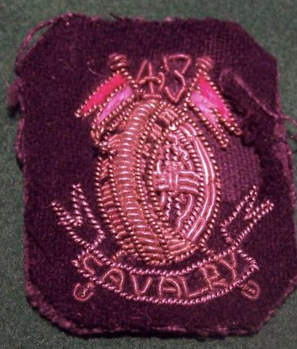
Responsibilities included delivering armoured machinery to front line and retrieving damaged armoured machinery for repair / refurbishment.

Second Battle of Arakan Timeline - 30 Dec 1943 - 6 Apr 1944
(following Allied forces defeat, by Japanese, in 1st campaign 1942-1943)
9 Jan 1944 | Indian 5th Division captured the coastal port city of Maungdaw, Burma, but the attack on Donbaik was halted by the Japanese.
5 Feb 1944 | Troops of Sakurai Force of Japanese 55th Division penetrated lines held by Indian 7th Division in Arakan, Burma undetected.
6 Feb 1944 | Japanese attacked the forward headquarters of Indian 7th Division in Arakan, Burma by surprise.
7 Feb 1944 | Japanese troops captured a divisional Anglo-Indian dressing station at Sinzweya, Burma and killed 35 medical staff and patients.
14 Feb 1944 | Japanese launched a major attack on the Anglo-Indian defensive position "Admin Box" at Sinzweya, Burma, capturing one hill on the perimeter.  Further reading: Burma '44: The Battle That Turned Britain's War in the East - James Holland  ISBN 0552172030
15 Feb 1944 | Anglo-Indian troops recaptured a hill they lost on the previous night at Sinzweya, Burma, suffering heavy casualties in the process.
22 Feb 1944 | Japanese Colonel Tanahashi, his troops beginning to starve while attacking Sinzweya, Burma, refused to make further attacks until food and supplies arrived.
24 Feb 1944 | Japanese Colonel Tanahashi ordered a retreat from Sinzweya, Burma without authorization.
26 Feb 1944 | The Japanese offensive on Sinzweya, Burma was called off, ending the Battle of the Admin Box.
6 Apr 1944 | Indian 26th Division captured Point 551 hill in Burma.

https://ww2db.com/battle_spec.php?battle_id=291

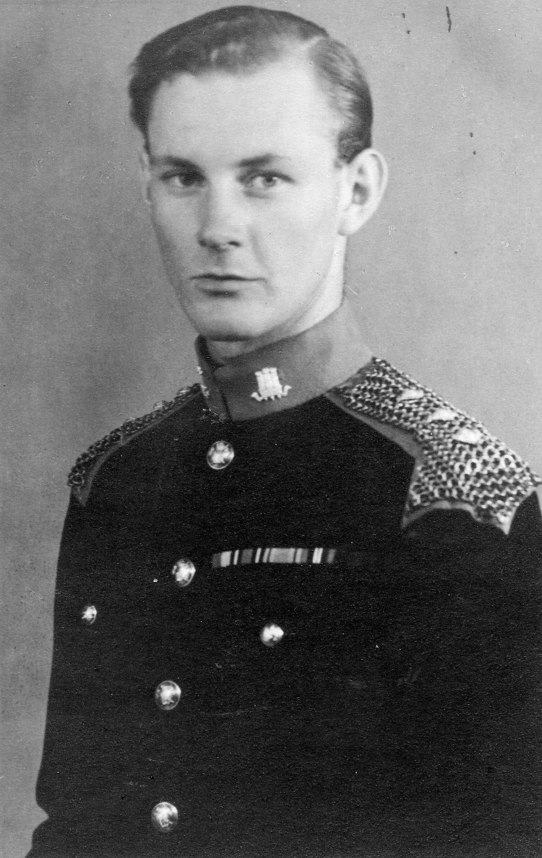
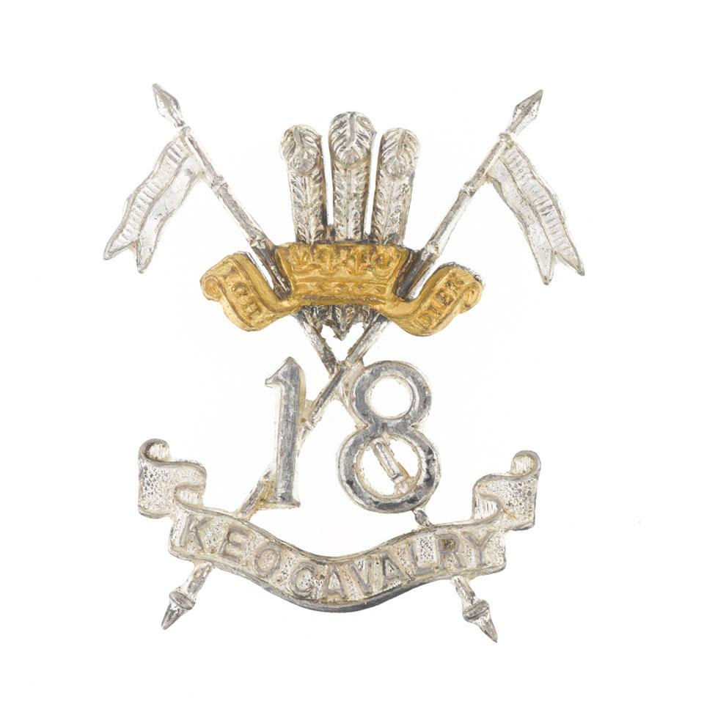
18th King Edward's Own Cavalry

